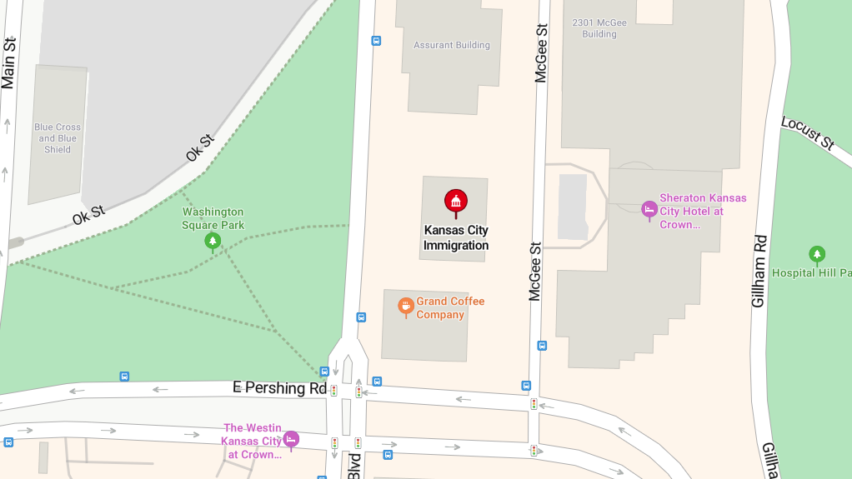
Parking for EOIR

Underground parking is available just north of 2345 Grand Blvd. It is $1 for the first 20 minutes.
Enter the building and proceed to level L.
Proceed to elevator bank marked 2-15.
Find the electronic pad by the elevators and press 5.
An elevator will open and take you to floor 5. The immigration court is the first door out of the elevators. You will have to go through metal detectors. Tell the officers you are there to register with EOIR. The receptionist will take your ID and find your application to finalize your registration.

